***User Guide***

*EPROJECT*

*ONLINE STATIONARY MANAGEMENT SYSTEM*

|  |  |  |
| --- | --- | --- |
| **Supervisor.** | **Miss Warda Jawed** | |
| **Batch.** | **2302E2** | |
| **Semester** | **HDSE 1** | |
| **Group.** | A | |
| **Serial No.** | **Enrollment Number** | **Student Name** |
| 1. | 1458683 | Qurat Ul Ain |
| 2. | 1458664 | Muneeb Ur Rehman |
| 3. | 1458357 | Muhammad Taha Shahid |
| 4. | 1457819 | Sundus Khalid |
| 5. | 1445155 | Umme Fatima |

*INTRODUCTION & SNAPSHOTS:*

*Access Panel:*

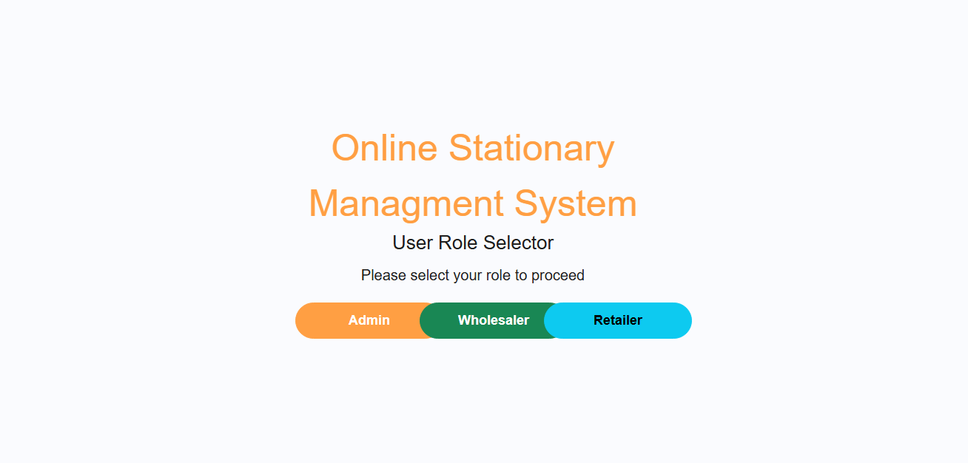

*Figure: 1 Access panel of our website*

This is the access panel of our website which has three buttons which you can click to go to the direct page.

*Admin Sign-In:*

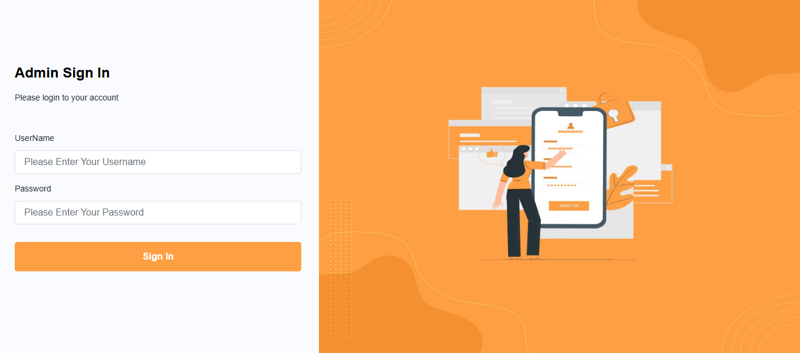

*Figure: 2 Admin Sign in page*

This is our admin sign-in page, which you can fill out to access the admin page.

*Wholesaler Sign-In:*

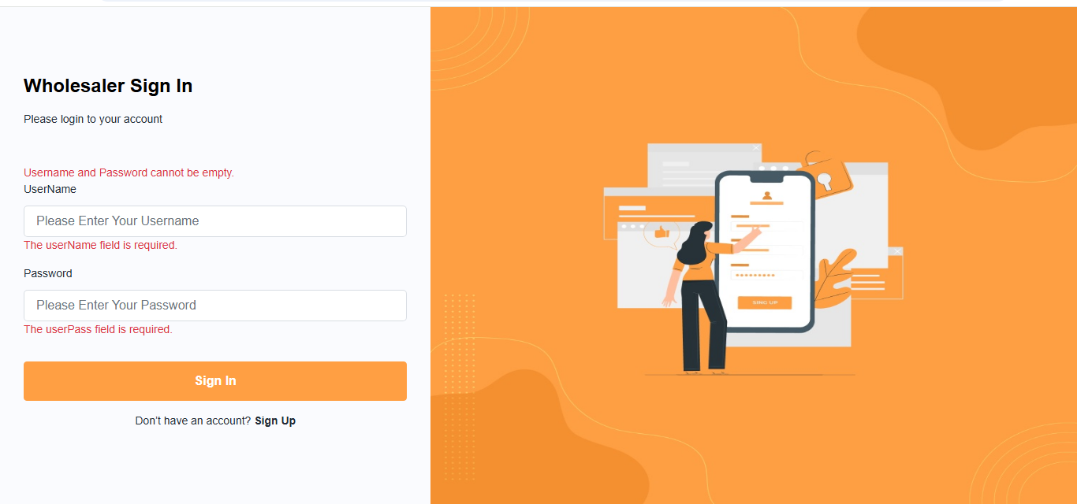

*Figure: 3 Wholesaler Sign in page*

This is our Wholesaler sign-in page, which you can fill out to access the Wholesaler page.

*Retailer Sign-In:*

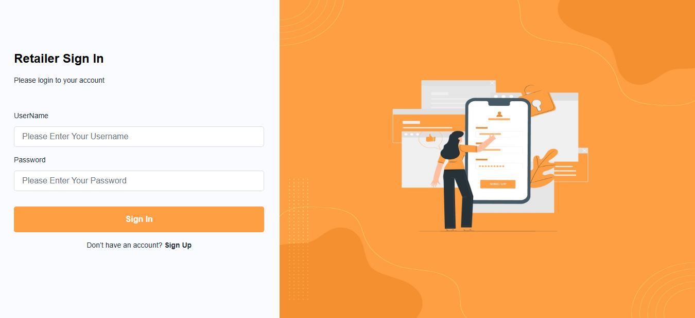

*Figure: 4 Retailer Sign in page*

This is our Retailer sign-in page, which you can fill out to access the Retailer page.

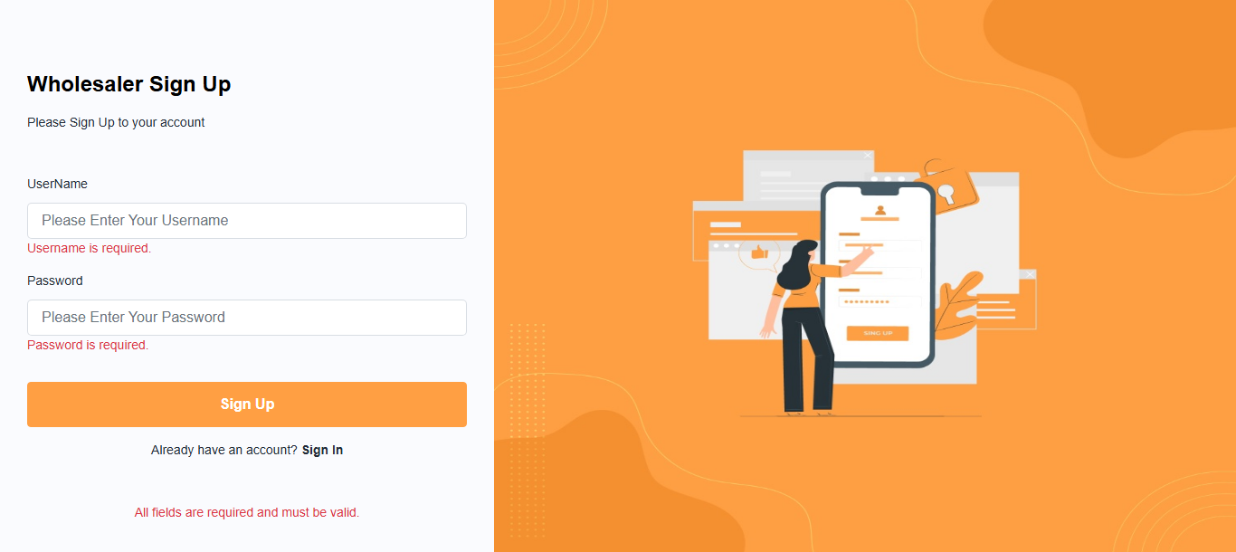*Wholesaler Sign-Up:*

*Figure: 5 Wholesaler Sign up page*

This is our admin sign-up page, where you will first sign up and then sign in.

*Dashboard (Admin):*

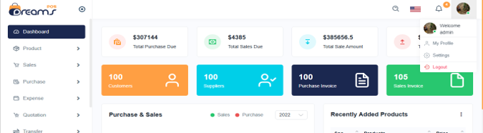

*Figure: 6 Dashboard Admin page*

This is our admin dashboard page, where you will access all pages.

*Dashboard (Wholesaler):*



*Figure: 7 Dashboard Wholesaler page*

This is our dashboard wholesaler page, where you will access all pages.

*product List:* 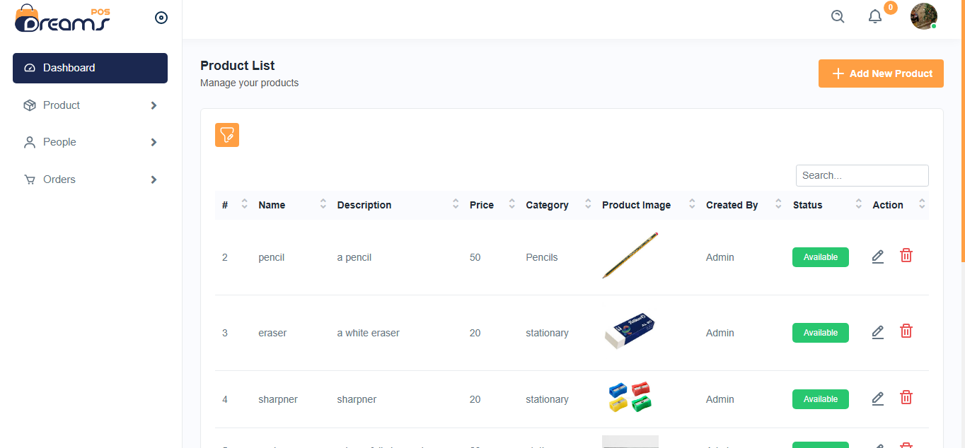

*Figure: 8 Product List page*

This is our product list page, where the products ordered by the user will be displayed, along with details such as the product's ID, name, description, price, and image.

*Category List:*

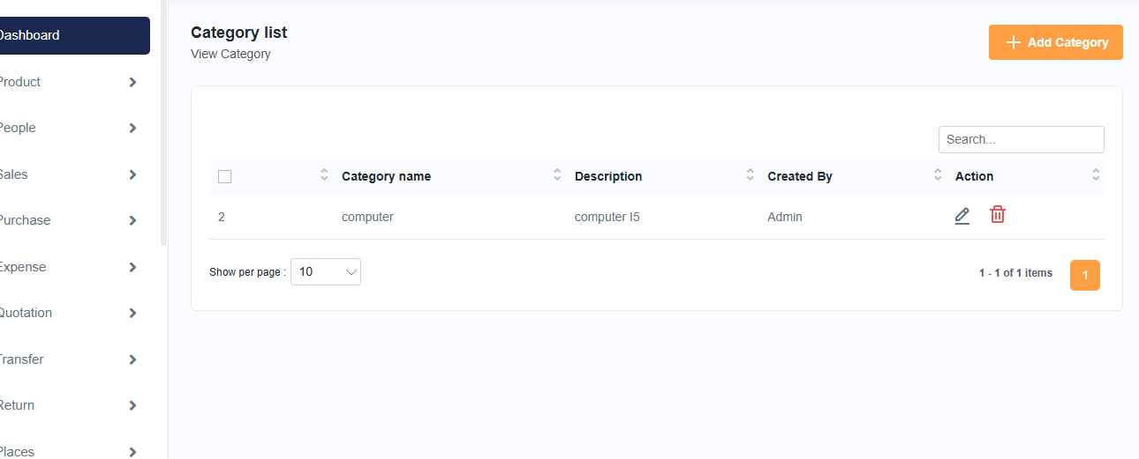

*Figure: 9 Category List page*

This is our category list page, where the products ordered by the user will be displayed, along with details such as the Category name, description and who is created.

*Add Category:* 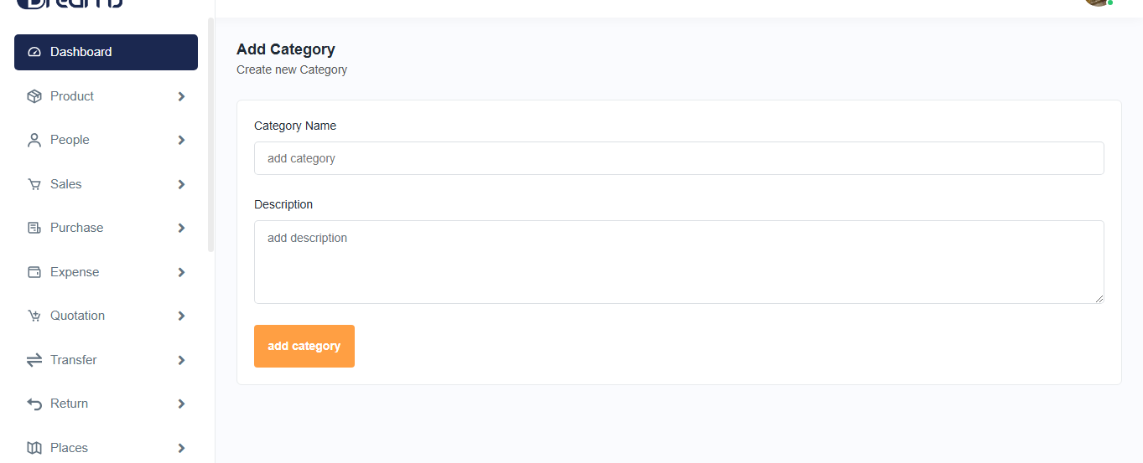

*Figure: 10 Add Category page*

This is our add category page, where we add product categories by entering the category name and category description.

*Product Add:* 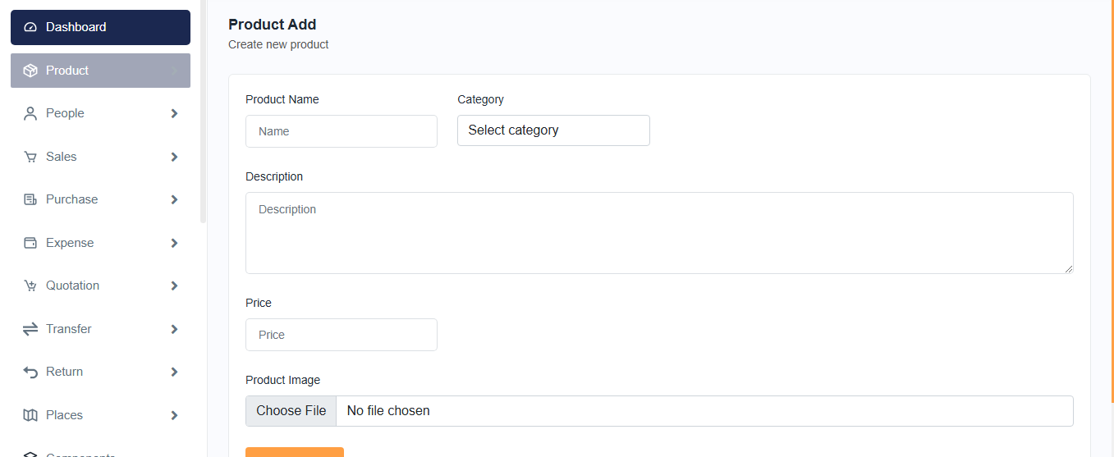

*Figure: 11 Product Add page*

This is our product add page, where we add product by entering the product name, category name, description, price or product image.

*Edit Product:* 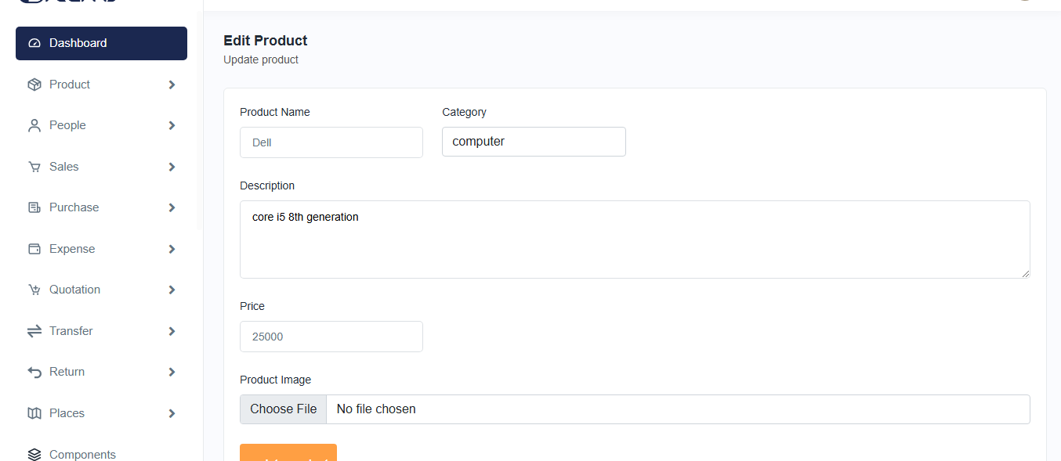

*Figure: 12 Edit Product page*

This is our product add page, where we add product by entering the product name, category name, description, price or product image.

This is our edit product page, where the product details can be updated.

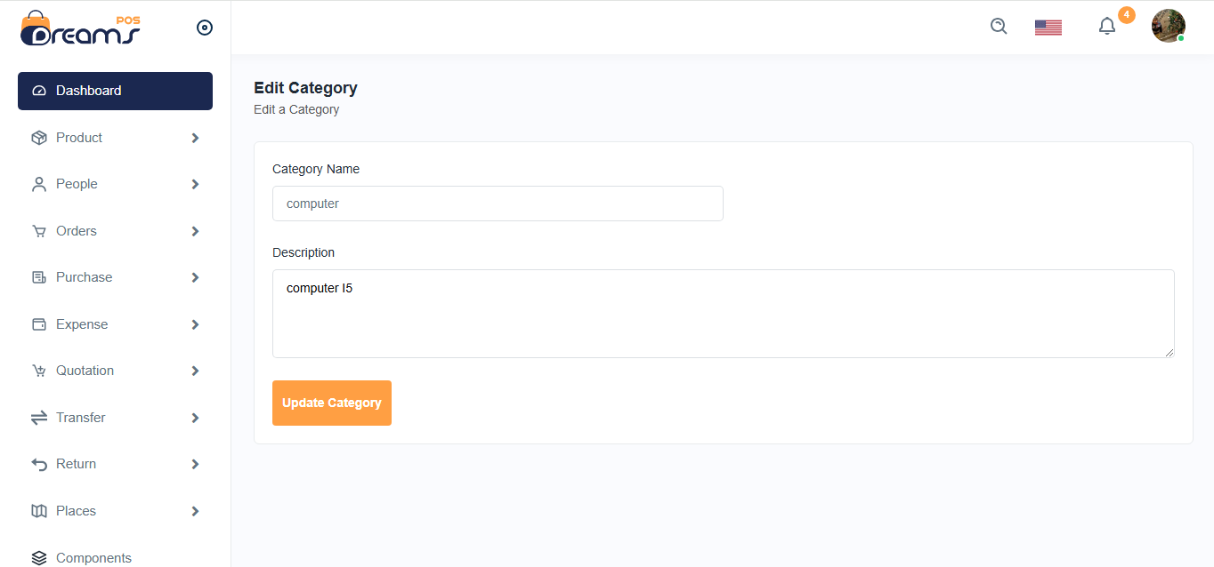*Edit Category:*

*Figure: 13 Edit Category page*

This is our edit category page, where we can edit category from category list by entering the category name, description.

In this page category details can be updated.

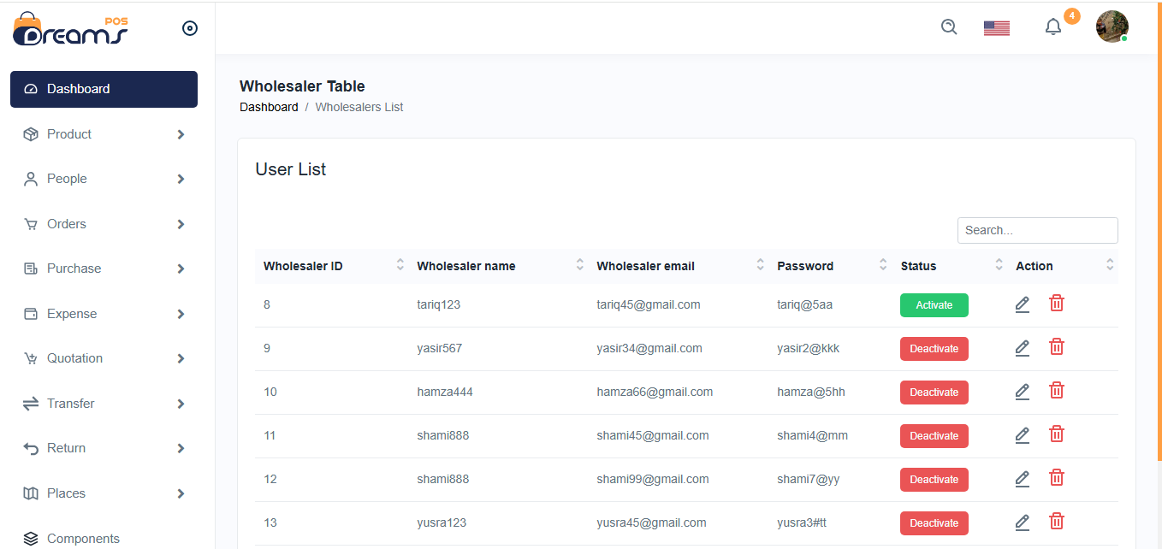*Wholesaler List:*

*Figure: 14 Wholesaler list page*

This is our wholesaler page, which includes ID, name, password, email, password, and status. In this page, we can activate or deactivate products.

*Wholesaler Product List:*



*Figure: 15 Wholesaler Product list page*

This is our wholesaler product list page, which includes Product ID, name, description price, category, image and action to show the product details.

*Wholesaler Purchase List:*

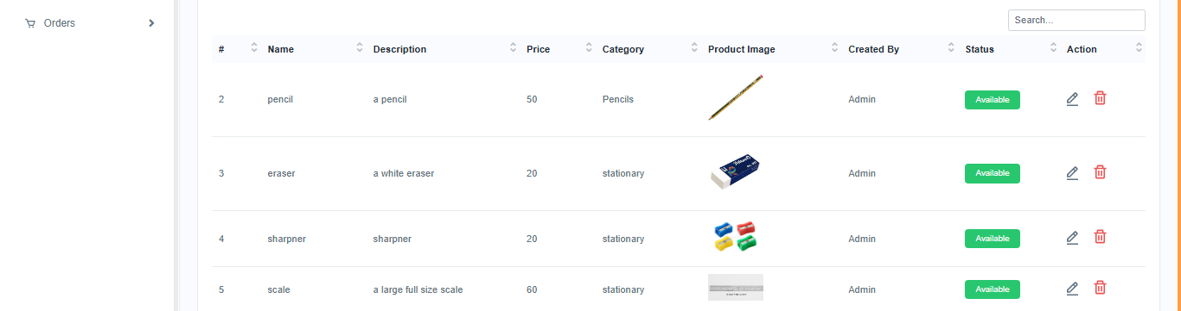

*Figure: 16 Wholesaler Purchase list page*This is our wholesaler purchase list page, which includes Product name, category name description price, quantity, total price image, status and action to show the purchase details.